You are asked to write a code that computes daily average precipitation over the basin for which the boundaries are specified in the file .BDY in the folder. Precipitation data for January 1951 are in the NETCDF4 prcp-195101-grd-scaled.nc

Steps to follow:

1. you have the basin boundaries and the gridded precipitation values (meaning that, for each day you will have a precipitation value for each cell)
2. overlap the basin to the grid in order to identify the cells (or partial cells) that belong to the basin
3. make a weighted average of the daily precipitation for this basin, being the weight the portion of cell that falls within the basin boundaries

The daily average precipitation over the basin will be computed as:

$$p_{avg}= \frac{\sum_{i,j}^{n_{rows},n_{cols}}{k_{ij}p_{ij}}}{\sum_{i,j}^{n_{rows},n_{cols}}{k_{ij}}}$$

with $k_{ij}$ the percentage of the cell *ij* belonging to the basin and $p_{ij}$ the daily precipitation value in cell *ij*

For example, assume you have one basin as in the following sketch:

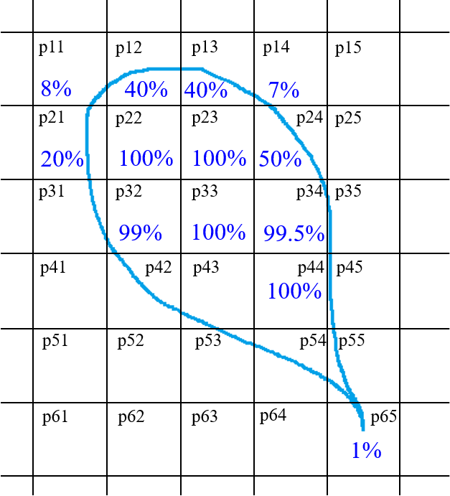

where the blue outline represents the basin boundaries and the black lines identify the precipitation grid.

$$p_{avg}=\frac{0.08p_{11}+0.4p_{12}+0.4p_{13}+0.07p_{14}+0.2p_{21}+p_{22}+p_{23}+0.5p_{24}+…+0.01p_{65}}{0.08+0.4+0.4+0.07+0.2+1+1+0.5+…+0.01}$$

**Notes**

1. You can solve the exercise in one of the following languages: Python, MATLAB, R
2. The code must be thoroughly commented, so that a random person that receives it knows exactly what the code does and how to run it (without having read this file)
3. Pay attention to the orientation of the .nc file (hint: plot one day of precipitation to see how the US shape looks like).
4. The file that you will send as result must contain all the functions you defined
5. The code must be written in a way that it can compute daily precipitation for a **generic** whole month of a **generic** year (you just get the data for January 1951 because it was easier), but attached also send me a .csv/.txt file for one day of your choice (provided that there are rainfall values, and not 0s everywhere) in which there is a value for cell. So, for example organize it so that it has the cell coordinates and the corresponding value of rainfall in that cell.